Lab: Reflection and Refraction
https://phet.colorado.edu/en/simulation/bending-light
Part 1: Reflection
In this lab we will study two important phenomena regarding the nature of light and how it behaves when it interacts when it travels from one medium to another. These two phenomena are known as reflection and refraction of light.

Once the simulation comes up, it will be in the Intro mode as indicated at the bottom of the screen. Will we use the ray model to investigate reflection and refraction of light. The first thing to do once you open the simulation is to take the protractor from the left-hand side and align it properly with the normal (as shown below) so that you can easily measure the angles of incidence and reflection. The normal is a line that is perpendicular to the surface where light interacts between the two mediums (air and water in the diagram below).
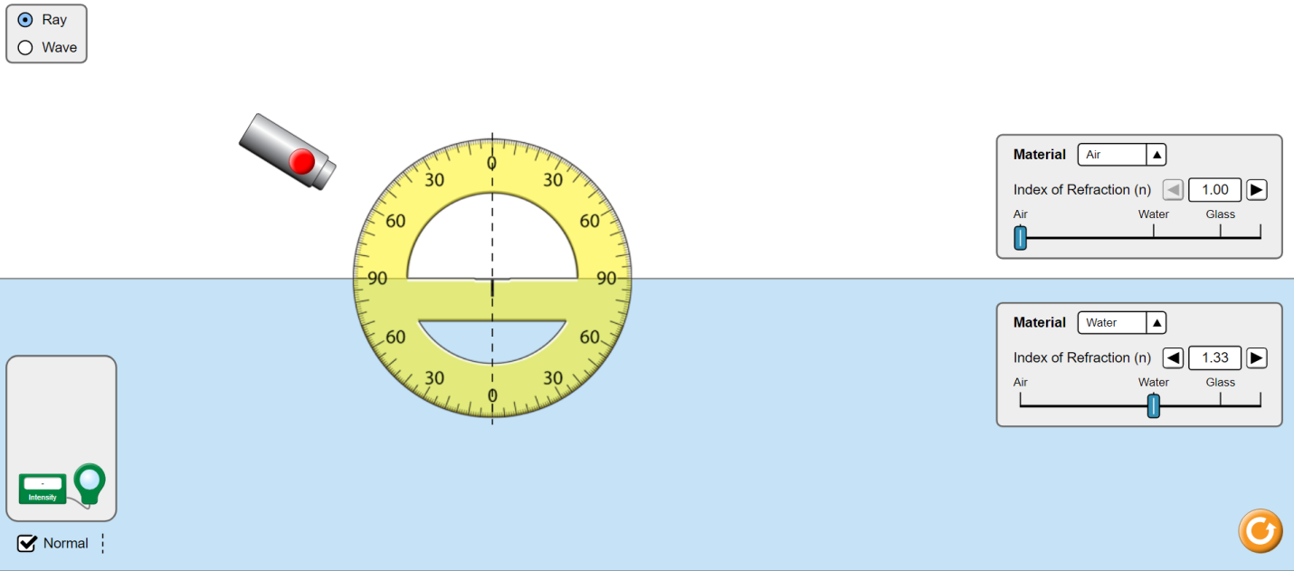
The angles themselves look as follows:
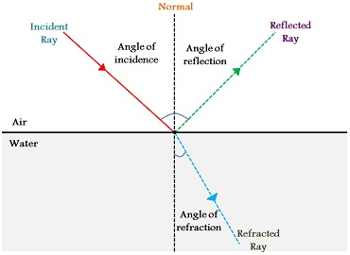

- Adjust the light source (laser pointer) to change the angle of incidence and select the red button to shine the light.
- Measure any four angles of incidence and their corresponding angles of reflection

Angle of Incidence | Angle of Reflection
0 | 0
20 | 20
40 | 40
60 | 60

What do you notice about the angles of incidence and reflection? Based on your observation what do you think is the Law of Reflection?

The incident ray and reflected ray behave in predictable ways. The angle of incidence always equals the angle of reflection, which is the Law of Reflection (θ_{i} = θ_{r})

Part 2: Refraction of Light
Next we’ll look at refraction, which is when light passes through different mediums.
- First go to the bottom of the simulation and select “More Tools”
- Next check off the box that says “Angles” on the bottom left
- Swap the mediums so that Water is on the top and Air is on the bottom using the dropdown menus on the right
- The simulation should now look like this:
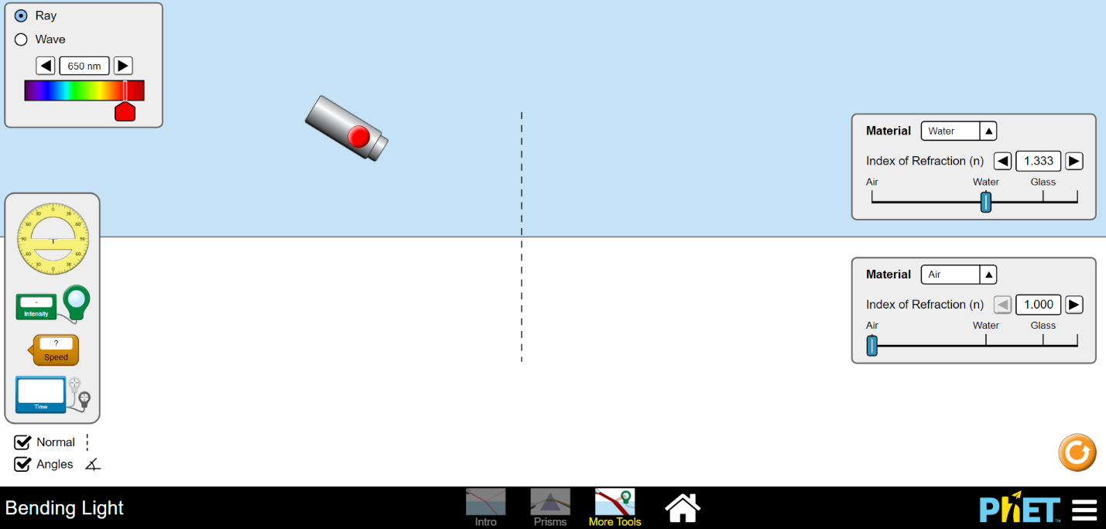

- Record the angles of incidence, reflection, and refraction

Angle of Incidence | Angle of Reflection | Angle of Refraction
0 | 0 | 0
30 | 30 | 41.8
45 | 45 | 70.5
60 | 60 | -

What do you notice about the angle of refraction after a certain angle? What happens to all of the light from the incident ray after that angle?

As the angle of incidence is increased, the angle of refraction also increases proportionally. At a certain angle of incidence, the light will refract 90 degrees and travel along the boundary between the two media. All of the light incident on the interface is reflected back into the incident medium.

